Intentional bugs  
<Acme-Gym> <2.0>

|  |  |
| --- | --- |
| ****Development team**** | |
| **Identifier** | DelEscLopPadSanVal |
| **Members** | Delgado Chaves, Gonzalo  Escobar Aguilera, Jesús Javier  López Muñoz, Juan Carlos  Padial González, Laura  Sánchez Reyes, Adrián  Valle Zarza, Juan José |
| **Testing team** | |
| **Identifier** | ReiCarMacLuq |
| **Members** | Carrascosa Oliva, Sergio  Macías López, Pablo  Reina López, Pablo  Luque Mendoza, José Manuel |
| **Indexing data** | |
| **Designers** | Delgado Chaves, Gonzalo  Escobar Aguilera, Jesús Javier  López Muñoz, Juan Carlos  Padial González, Laura  Sánchez Reyes, Adrián  Valle Zarza, Juan José |
| **Testers** | Carrascosa Oliva, Sergio  Macías López, Pablo  Reina López, Pablo  Luque Mendoza, José Manuel |
| **Notes** |  |

|  |
| --- |
| ****Effectiveness**** |
| 3/3 |

Table of contents

Bug in use case <002> <Searching workouts > 2

Bug in use case <003> <Writing annotations> 2

Bug in use case <005> <Browsing a trainer's curriculum > 2

# Bug in use case <002> <Searching workouts >

Description

The injected bug is that the text for the search box displays a strange combination of numbers and characters instead of any text, in both languages.

Results

*It was found.*

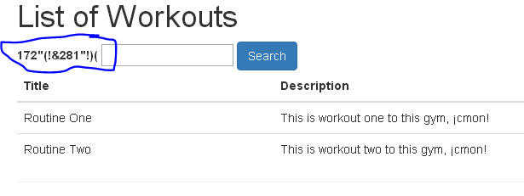

# Bug in use case <003> <Writing annotations>

Description

The injected bug is the lack of a 'Create annotation' button in the workouts list, which means the use case cannot be carried out at all.

Results

It was found.

# Bug in use case <005> <Browsing a trainer's curriculum >

Description

The injected bug is that, on the trainers view from where curricula can be accessed, the English view displays the title as 'List of curricula' instead of 'List of trainers'.

Results

We find the bug after the first testing. But no test required access to the list of coaches, and therefore we did not check that view.